Overview

There are 3 new BPEM cases in Post Cutover to Interval Billing applicable to GSD customers having rate category GSD_1120 or GSD_1130 whose demand is being calculated over the air.

- EB-65: OTA Demand was Estimated

This is a temporary case that will only be active during Post Cutover to Interval Billing ramp-up period which is planned to be 30-60 days. A case will be created if estimated intervals were used by IEE to determine the max demand and passed to SAP as a billing determinant.

Once Customer Billing decides that this case category is no longer needed, contact production support and have them deactivate this case category by turning off the TVARVC global variable ZBL_EST_DMD_CHK_VALID.

- EB-66: OTA Demand Missing or Invalid

The Missing Demand BPEM case will only created if the demand value is not provided by IEE or if IEE failed to process max demand on the billing cycle of customer. This is rare case and is created to manage exceptional cases where the IEE system is not able to process max demand and post it to SAP for billing.

The Invalid Demand EMMA case will be created if IEEE returns a negative value or a value greater than 999,999.

- EB-67: Interval Value has changed

There would be scenarios where the meter read data for interval KWH reads will be edited in IEE after the cycle has been billed. A BPEM case will be generated based on update and modification carried out in IEE.

This is also a rare occurance and customer billing needs to validate that the max demand determined by IEE after the interval update warrants a cancel rebill of the period. A cancel/rebill can be performed based on the outcome of the validation.

Business Process Procedure Overview
Overview of Process to be followed
- Open the BPEM case
- Perform necessary functions to resolve the case
- Close the BPEM case

Procedural Steps

Open the BPEM case
Using transaction /EMMAX/CLS, the Post Cutover cases will be assigned automatically based on existing prioritization using the Get New Cases button.

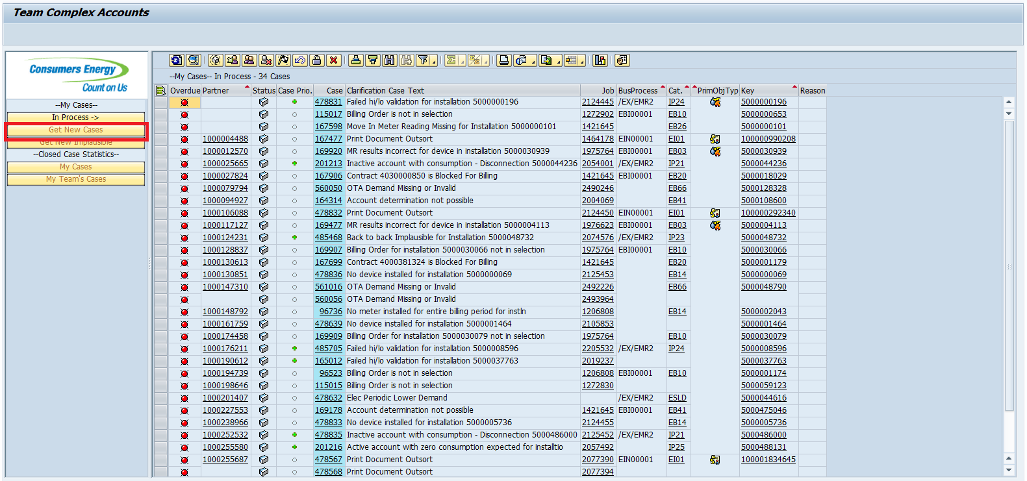

New Post Cutover cases can also be listed and selected with transaction /EMMAX/CL using the following selection parameters:

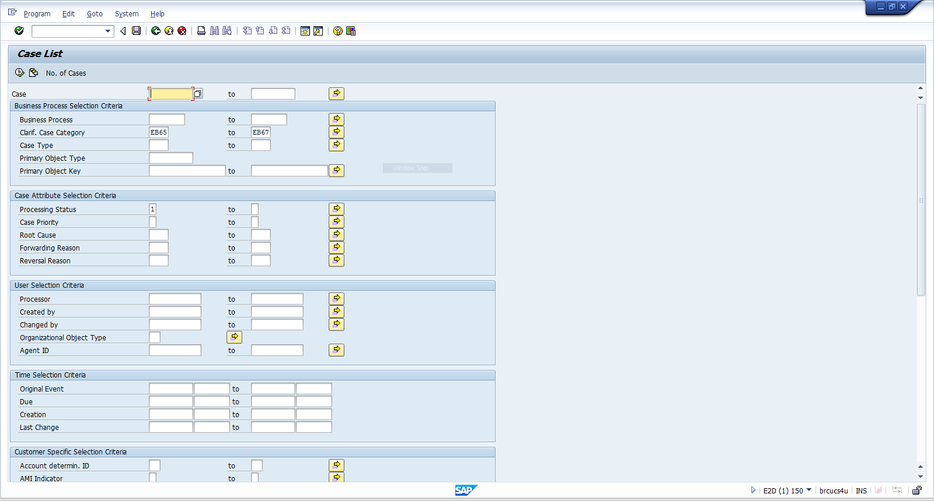

Double-click on the Clarification Case Text, to open the case in change mode. If you only want to open the case in display mode, double-click on the case number.

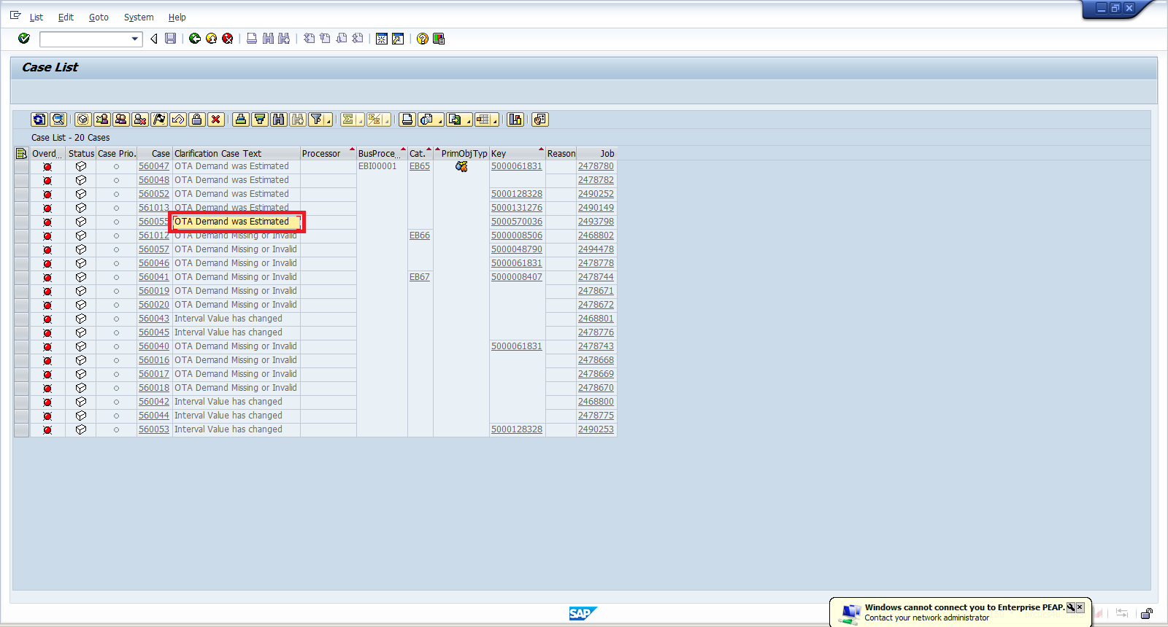

Perform necessary functions to resolve the case

The following functions are available from the case:
- View of Meter Reading Results and Billing Documents
- List of available Solution Process that can be executed
- View of the Service Orders (Service Orders tab)
- Ability to forward the case
- Ability to update the Status and provide a Root Cause
- Ability to enter notes (scroll downfrom the Main Data tab)
- Ability to execute solution processes

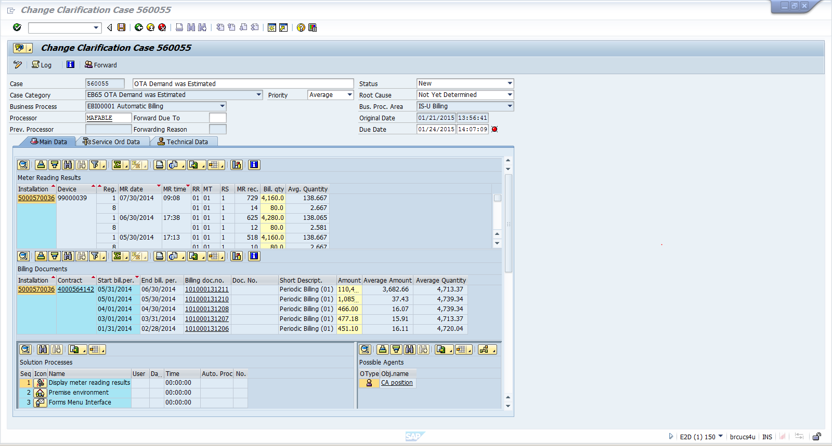

Close the BPEM case

Once processing of the case has been completed and the user decides to close the case, the following action are required:
- Set the Status to Completed
- Select a Root Cause
- Enter a mandatory note
- Save the case

